If you are creating a new direction to administer, please refer to the setup guidance:
New-Patient_GP-Direction-to-Administer-Medication-guide-V1.1-1.docx

Amending Medication

To make amendments to an existing DTAM the GP Direction to Administer Medication EOL Wak V2 template should be completed in SystmOne.

If the amendment is for a PRN medication and multiple PRN medications exist, every PRN medication must be re-transcribed into the template. Likewise, if the amendment is for a syringe driver medication and multiple syringe driver medications exist, all syringe driver medication must be re-transcribed onto the template.

The reasoning behind this is that the Adult Unscheduled Care Team use a separate SystmOne template which pulls through what was last prescribed in the GP Direction to Administer Medication template. If existing drugs are not re-transcribed onto the template, the community nurses will not be able to see these drugs and they will not be able to administer them to the patient.

To save having to re-transcribe all the drugs manually it’s possible to copy the values from the previous template: How_to_Copy_Previous_Values

Alternatively, data can be re-entered manually: How_to_Manually_Complete_the_Template

Administered Medication

If you want to view what has already been administered to the patient by the Adult Unscheduled Care Team, look at the DN Administered Medication View on the template.

Inform Mid Yorks About the Change/s

Once you have updated the template with the required change/s, you will need to notify the Adult Unscheduled Care Team.

- Click on the Existing Patient button at the bottom of the screen
- Click on the For drop down and select Mid Yorks Adult Unscheduled Care
- Click the User Group radio button, then select Single Point of Contact
- Click on the Task drop down and select Direction to Administer Medication
- Type Direction to Administer Medication, plus any notes in the text box at the bottom then click Ok
- Click Ok to close the template, then Save the record to send the task

How to Copy Previous Values
- Select the GP DTAM template on your clinical tree (if the template does not show here and you’re unsure how to add this, ask a member of your admin team)

- Right click over the drugs last prescribed on the right and ‘Copy Previous Values’.

- This will launch the GP DTAM template with the values last recorded in the template which can be amended as required
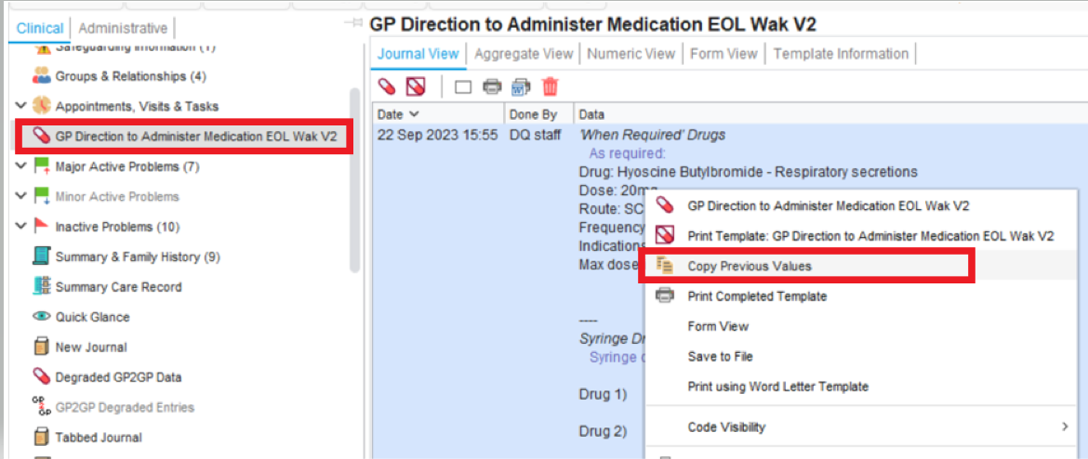

If you cannot access the template from your clinical tree, whilst in a patient record, open the template using the search functionality in the bottom left of SystmOne by typing GP Direction to Administer Medication EOL Wak V2.

Opening the template this way will not automatically pull through previously prescribed drugs but previous values can be copied and pasted.

- On the right-hand pane of either the PRN drugs or syringe driver page left click on the previous data entered.
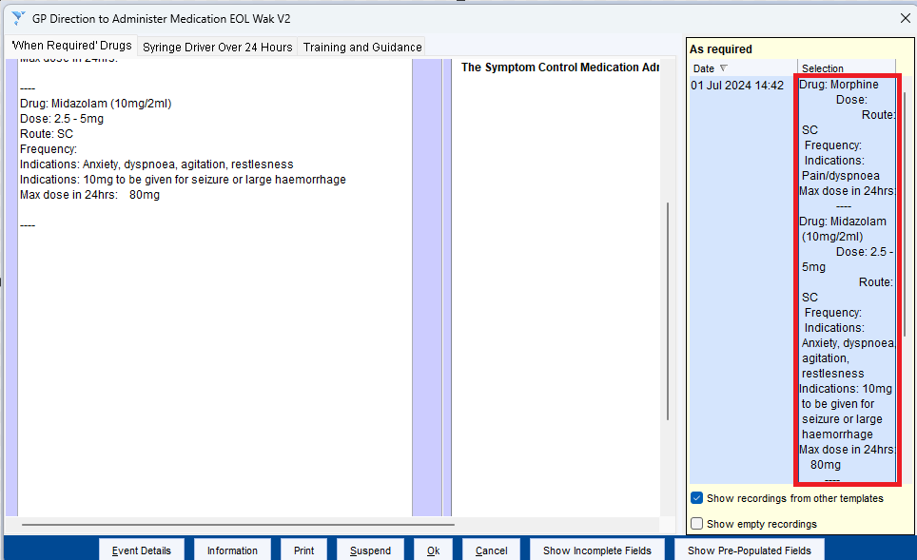

- Copy the data using Ctrl & C on your keyboard.
- Paste the data into the PRN/syringe driver entry box/es on the left and amend as required.

How to Manually Complete the Template

Open the patient record in SystmOne and access the template by typing in GP Direction to Administer Medication EOL Wak V2 in the bottom left of SystmOne.

‘When required’ drugs
- Click on the Add preset notes button to the right of the As required section.
- Select the relevant drug(s) from the preset (you can add multiple by holding down the Ctrl key and clicking the options that you want). If the drug that you need is not there select the bottom option in the list.
- Click Ok
- The details will appear in the ‘As required’ section. Please complete the dose, frequency and max dose in 24 hrs for each drug.

Syringe driver details

- Type the drug name, dose and diluent in the Syringe driver section
- Delete either water or Sodium Chloride as appropriate from the Administration of medication under patient specific direction section at the bottom.

